**Invoicing Centre**

The Invoicing Centre is used to create and edit invoices. Different sections will be examined and each function will be explained in this document.

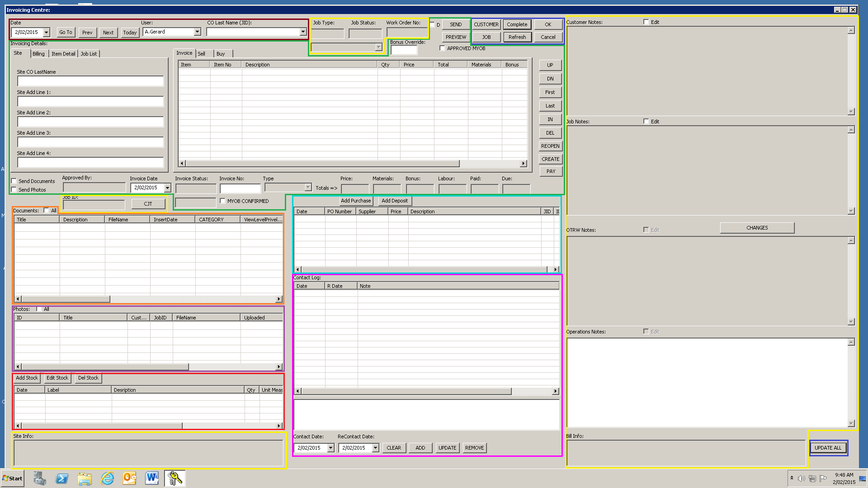

**Legend:**

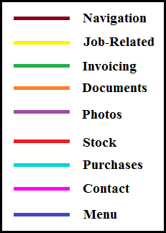As seen above there are multiple sections to the invoicing centre. Each section will be examined individually, with each function being explained as well.

Navigation

C:\Users\Jaws\Desktop\Work Pics\inv-3.png

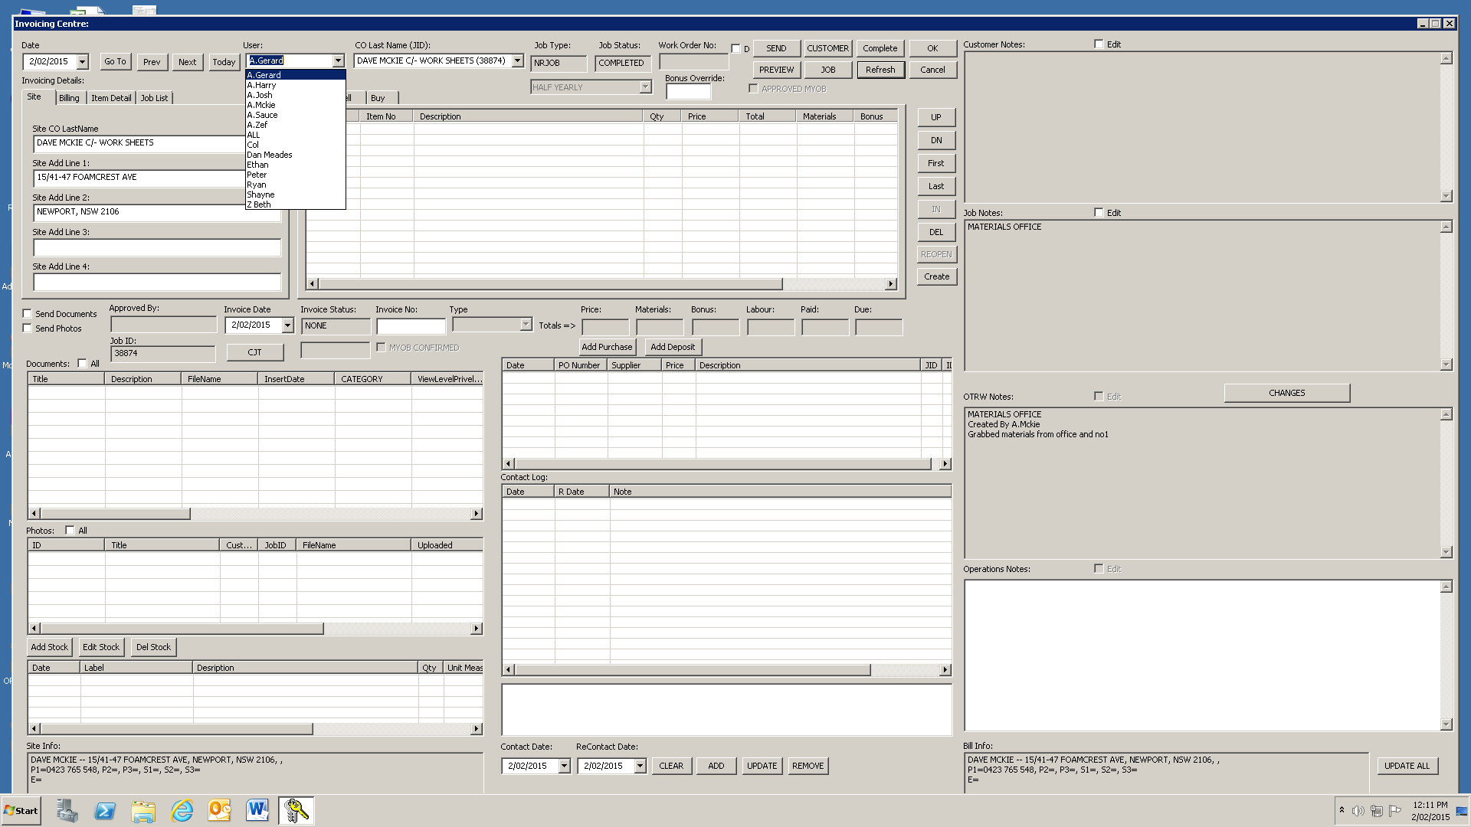 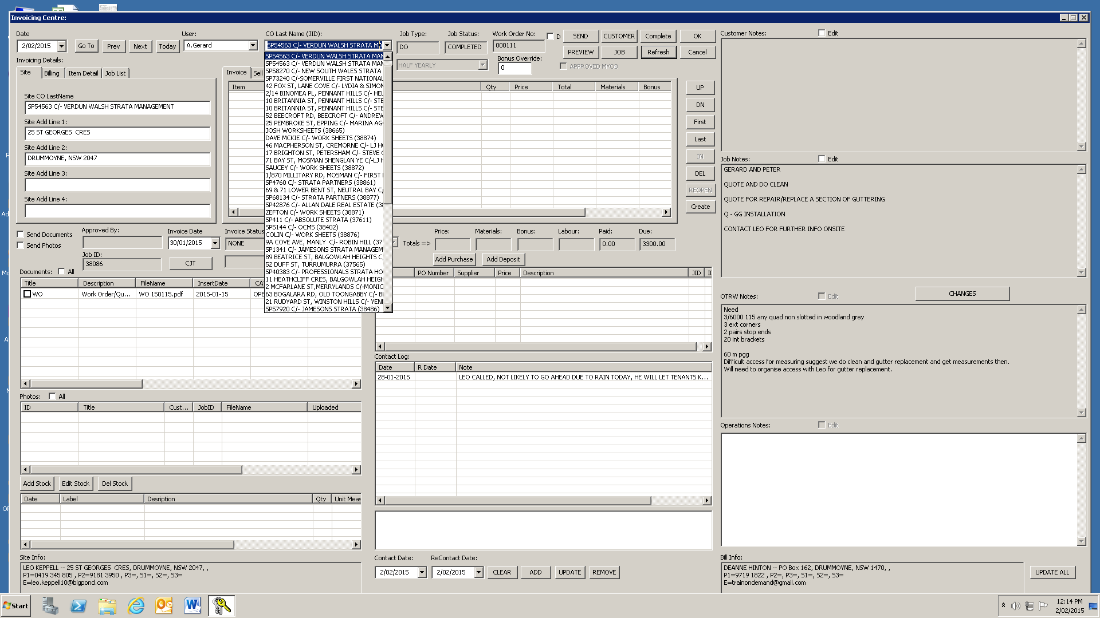

The controls here are used for navigation. The “Date” drop down list will give you a calendar to choose a date to load a job from. The “Go To” button will then load jobs from that day.

The “Prev” (Previous) and “Next” buttons will simply go back or forward by one day. The “Today” button will take you to the current date.

The “User” drop down list filters jobs to show jobs related to the specified user.

The “CO Last Name” drop down list allows you to select a job by customer name/job name.

Job-Related

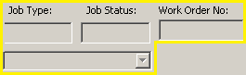 C:\Users\Jaws\Desktop\Work Pics\Invoicing Centre.png

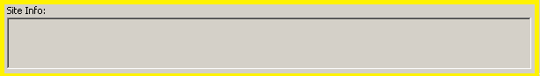

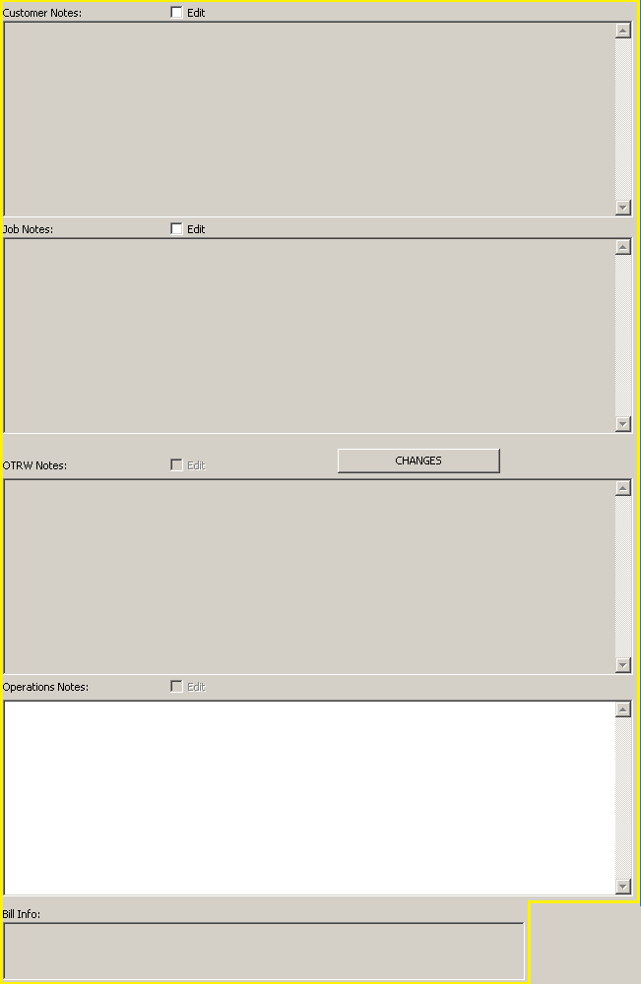The Job-Related sections of the invoicing centre (highlighted in yellow) give you various details about the selected job.

For example

* Job Type,
* Job Status,
* Work Order Number,
* Notes Relating to the job,
* Site/ Billing Information
* Job ID.

The “CJT” button allows you to edit the job times for the OTRW.

The “Edit” check box in the notes section will let you edit the notes relating to the job.

* Customer Notes are notes that can be seen from within all jobs
* Job Notes are specific to the current job
* OTRW notes are job notes added by the OTRW in the field
* Operation notes are notes added after job is complete

The “CHANGES” button will give you the following screen:

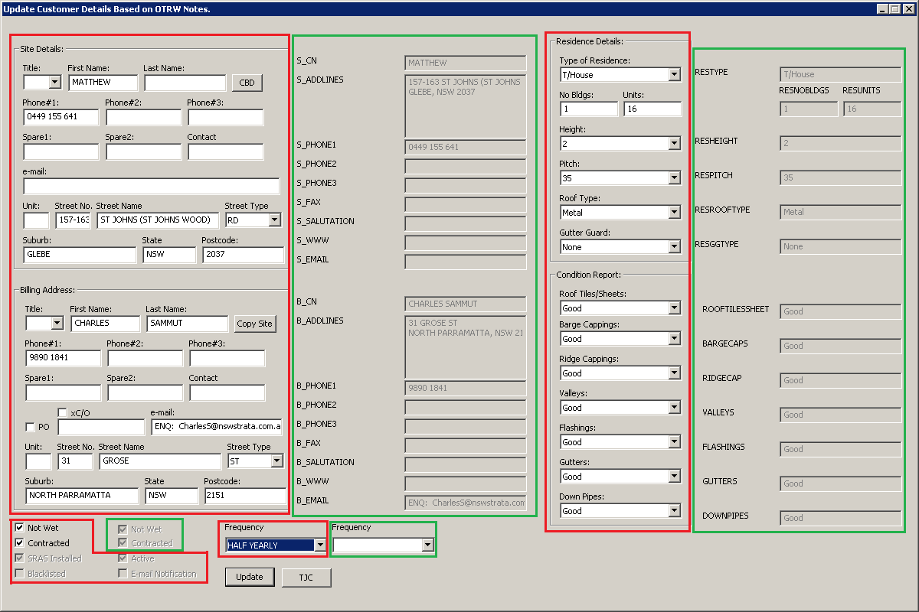

C:\Users\Jaws\Desktop\Work Pics\legend.png

From here you can view and edit details relating to the selected customer. The purpose of this screen is to allow the admins to see the changes made in the field by the OTRW. The admins can then update the systems details of that customer with the new details given by the OTRW.

The “Update” button will update any changes the admins enter into the system, whereas the “TJC” (Transfer OTRW Job Changes) will change and update the details into the system based off the OTRW’s updated details.

Invoicing

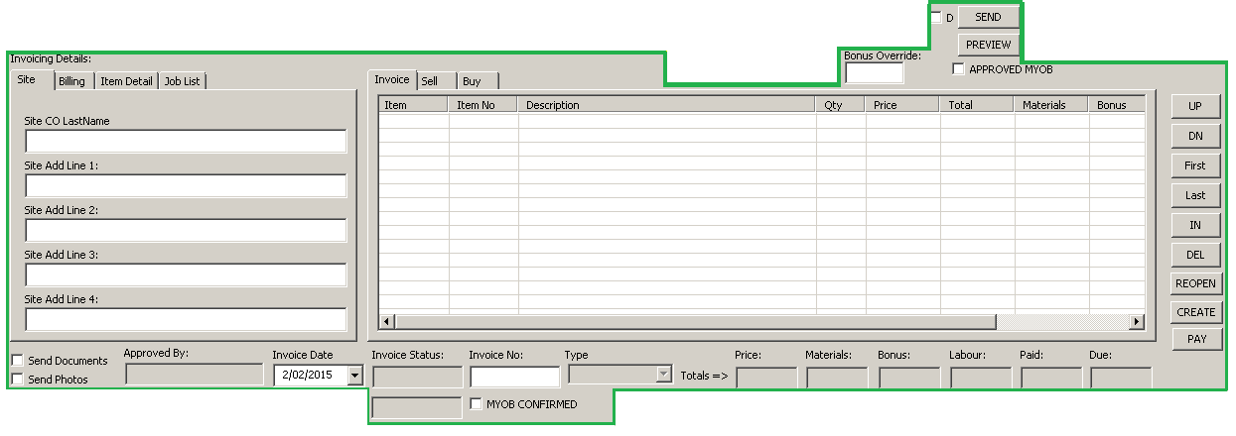

In the invoicing section, invoice details can be viewed and edited.

The left panel provides details about the job itself, with different details being provided depending on which tab you have selected.

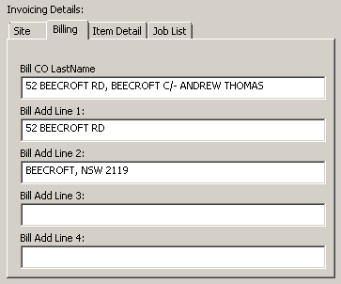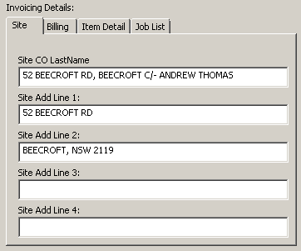

**Example: Site Details**

**Example: Billing Details**

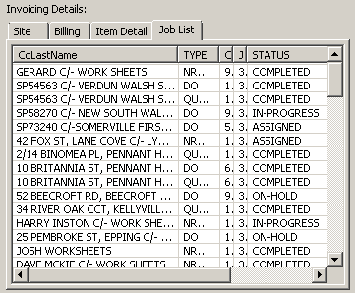

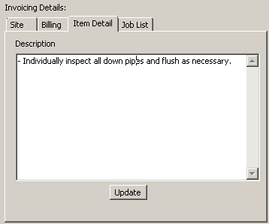

**Example: Job List**

**Example: Item Details**

The panel to the right gives details about items used on that job.

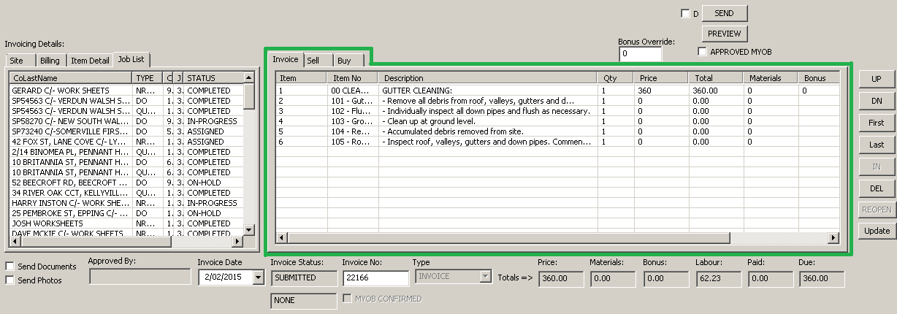

The “Invoice” tab gives details about the items used on the job.

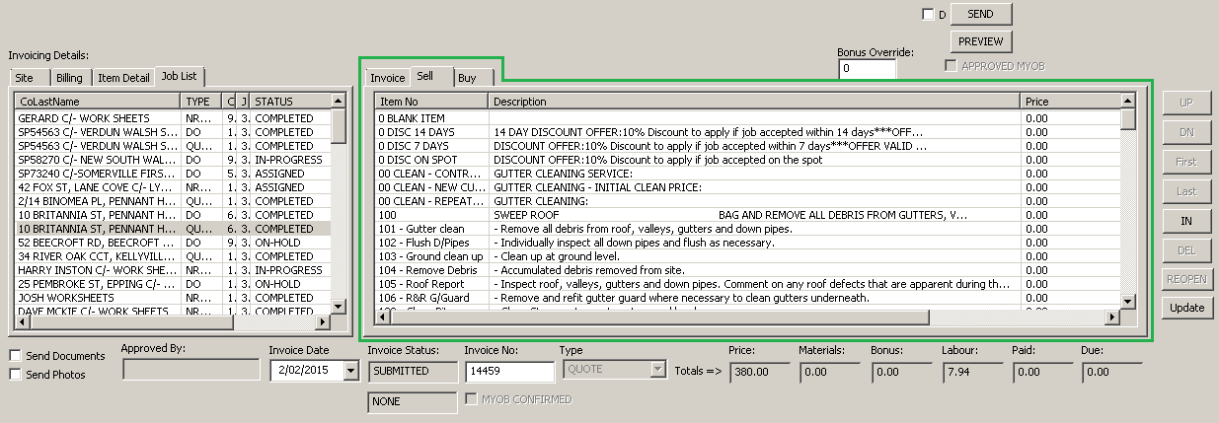

The “Sell” tab gives a list of items that can be added to the invoice.

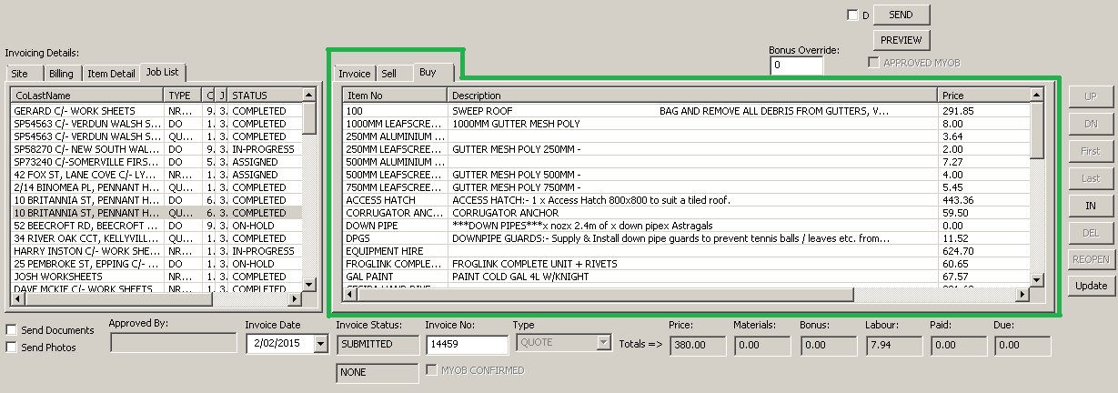

The “Buy” tab shows the list of items which can be bought by the company.

The buttons and boxes located around the middle panels provide some additional details relating to the invoice as well as some other functions.

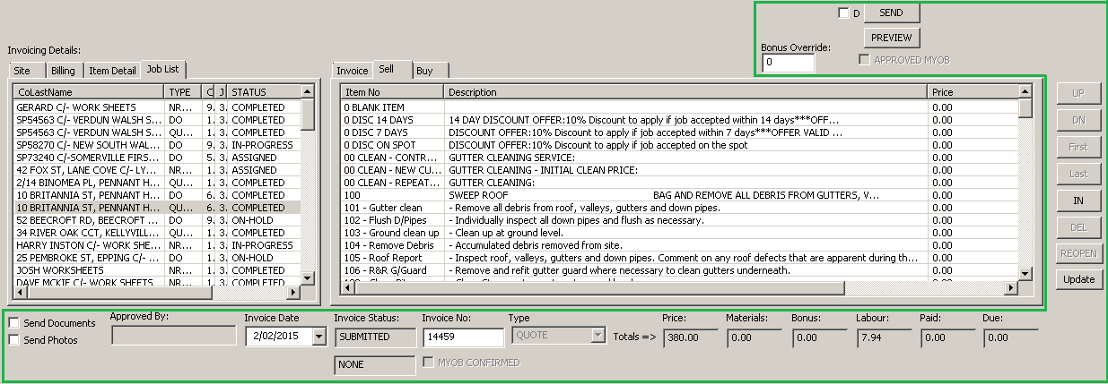



* “Send Documents” & “Send Photos” Checkbox sends the selected Documents/Photos with the invoice.
* The “Approved By” box shows who approved the quote.
* The “Invoice Date” box is the date of the invoice. This normally corresponds to the date the job was done.
* The two boxes under: “Invoice Status” show the current status of the invoice, in the example above it is “SUBMITTED”. And the box below, which is the payment method, is “NONE”, as no payment has yet been received.
* The “Invoice No” box shows the invoice number.
* The “Type” box shows what type the invoice is, in the example above it is a “QUOTE”.
* The “Price” box shows the total of the invoice sale price.
* The “Materials” box shows the materials cost.
* The “Bonus” box shows bonus given for the job.
* The “Labour” box shows the labour cost.
* The “Paid” box shows how much has been paid.
* The “Due” box shows how much of the invoice is yet unpaid.
* The “PREVIEW” button will generate a preview of the invoice or quote as a pdf. Details on this quote/invoice include:

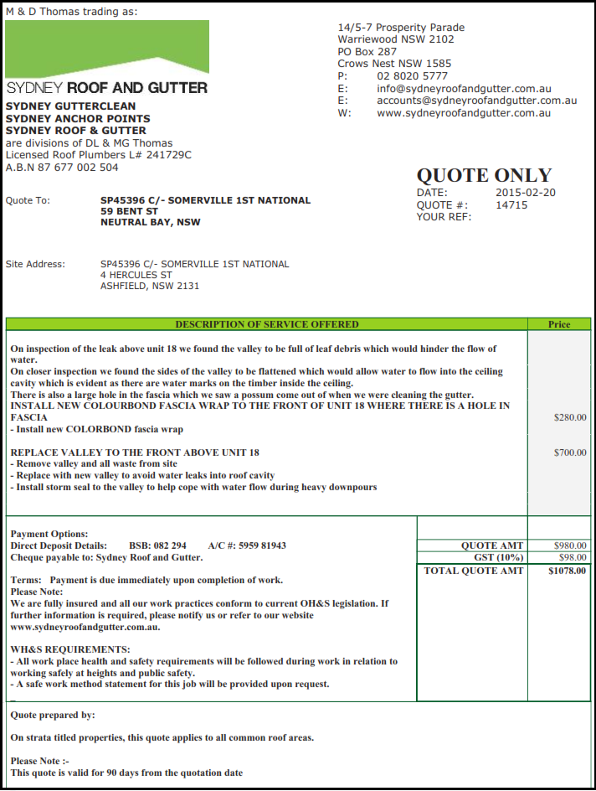Quote

* Basic contact details, such as: Company Name, Address, Phone Number, Email Address, etc.
* The date of the quote, and the quote number. Customer related reference number. Who the quote is to. The site address.
* Description of service offered. The price estimated.
* The payment option and terms. The WH&S requirements. The quote amount, GST amount, and total amount (Including GST).
* Who prepared the quote, and additional information.

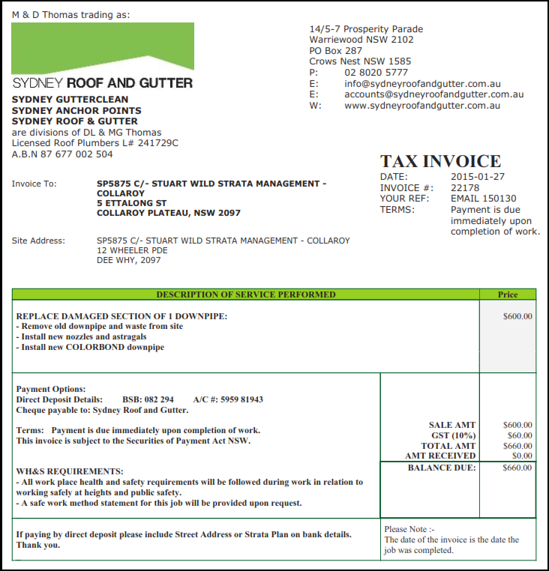Tax Invoice

* Basic contact details, such as: Company Name, Address, Phone Number, Email Address, etc.
* The invoice date and number. The customer related reference number. The payment terms. Who the invoice is to. The site address.
* Description of service performed. The price of provided service.
* Payment option and terms. WH&S requirements. The sale amount. The GST amount. The total amount (GST included). The amount received. The amount still waiting to be paid.
* Additional information.
* 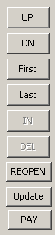The “UP” button will move an item in the item panel up.
* The “DN” button will move an item in the item panel down.
* The “First” button will move an item in the item panel to the first slot.
* The “Last” button will move an item in the item panel to the last slot.
* The “IN” button will insert a new item.
* The “DEL” button will delete an item from the items panel.
* The “REOPEN” button will reset the invoice to a submitted status.
* The “Update” button will update the invoice.
* The “PAY” button will open the pay dialogue box.

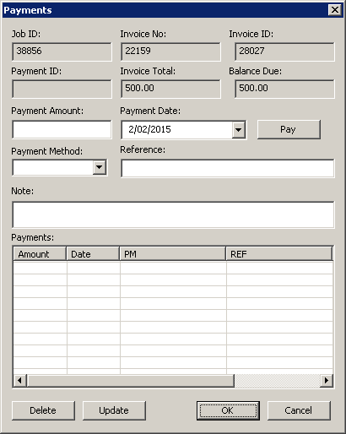

The Payment Dialogue Box

The purpose of the payment dialogue box is to mark an invoice as paid. To do so:

* The Payment Amount must be entered.
* The Payment Date must be entered.
* The Payment Method must be chosen.
* If necessary, a reference can be given.
* For further detail, a note can be left.

If there is a payment in the payment list, the “Delete” button can be used to delete that payment from the invoice.

If a payment from the payment list is selected you can use the “Update” button to update any changes you made with the payment.

* 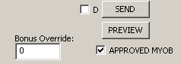The “D” checkbox will tell the system to send a deposit request instead of a quote.
* The “Bonus Override” box allows the admin to allocate job bonus to another user.
* The “SEND” button will open a Send Customer E-mail form.
* The “PREVIEW” button will give you a preview of the invoice as a PDF.
* Checking the “Approved MYOB” checkbox allows the invoice to be sent to MYOB.’

Having the “D” checkbox checked and clicking preview will present the following screen.

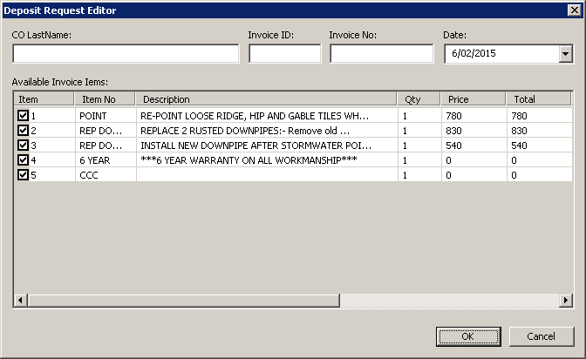

After selecting items to be added as deposits, click “OK” to see a preview of the deposit as a PDF.

The Send Dialogue Box

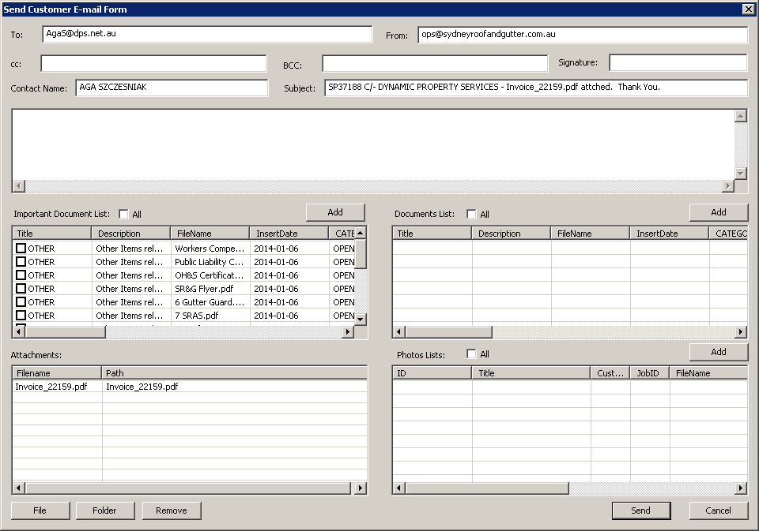

At the Send Customer E-mail Form box, you can:

* Send Invoices to different customers.
* And attach documents and/or photos to the email.
* View any documents/photos that are attached to be sent with the email.
* Remove any documents/photos that are attached to be sent with the email.
* Attach contents of a folder to be sent with the email.
* Attach a file to be sent with the email.

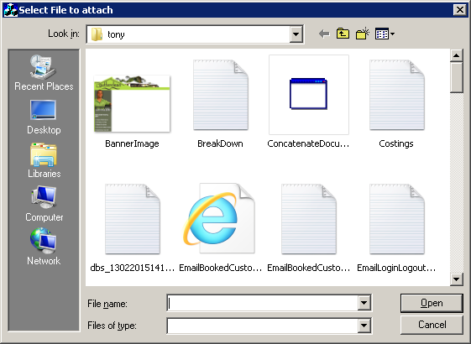 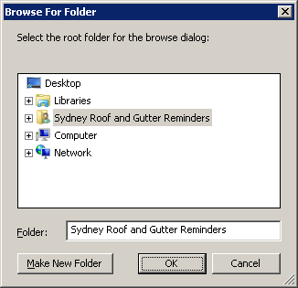

Documents

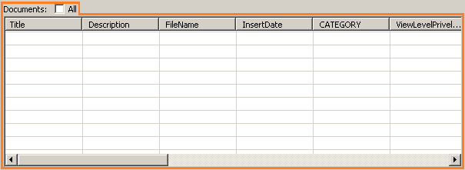

The documents control list allows you to:

* Upload documents via drag and drop
* Open, download and delete documents
* Attach documents to the invoice for sending

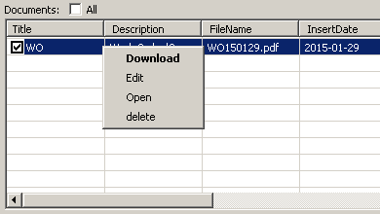

Right clicking on one of the attached documents will give you a menu allowing you to:

* Download the document.
* Edit the document properties.
* Open the document.
* Delete the document.

**NOTE: These options are only available if the document’s checkbox is checked.**

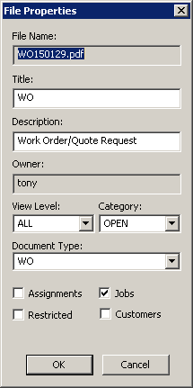

Clicking “Edit” will give you this screen. Here you can change:

* The Document Title.
* The Document’s Description.
* 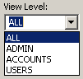The View Level of the document.
* 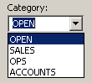The Category of the document.

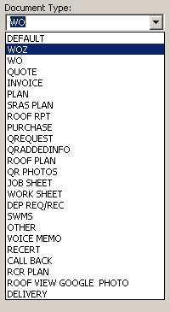

* The Document Type.

The “Assignments” and “Jobs” checkboxes are deprecated functions.

The “Customers” checkbox ensures the document is shown with all jobs relating to the selected customer. **NOTE: This does not apply to the website version.**

The “Restricted” checkbox allows admins to hide the document from all users except the owner of the document.

**NOTE: This only applies to the website version.**

Photos

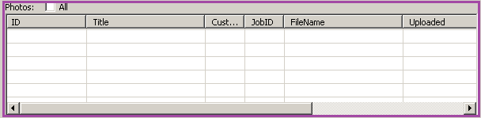

The photos control list allows you to:

* Upload photos via drag and drop.
* Open, download and delete photos.
* Attach photos to the invoice for sending.

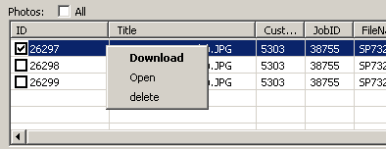

Right clicking on one of the attached photos will give you a menu allowing you to:

* Download the photo.
* Open the photo.
* Delete the photo.

**NOTE: These options are only available if the photo’s checkbox is checked.**

Stock

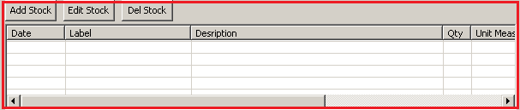

From the Stock section of the invoicing centre, you can:

* View stock items that are used on the job by the OTRW.
* Add stock items to the invoice.
* Edit stock item associated with the invoice.
* Delete stock items associated with the invoice.

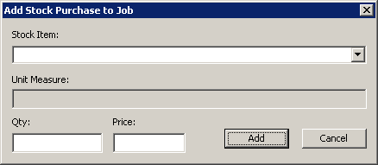

The “Add Stock” button will give you this window, allowing you to:

* Choose a stock item from a drop down list.
* Choose the quantity of the stock item.
* Choose the price of the stock item.

Clicking add will then add the selected stock item to the invoice. Clicking the “Edit Stock” button will give you the same screen to edit stock item details.

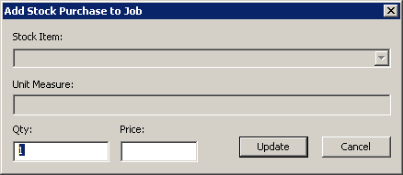

Purchases

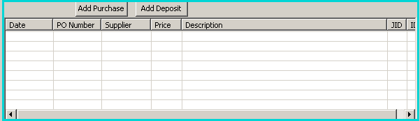

The purchases section of the invoicing centre allows you to add a purchase order to the job.

**NOTE: The “Add Deposit” button is currently not in use.**

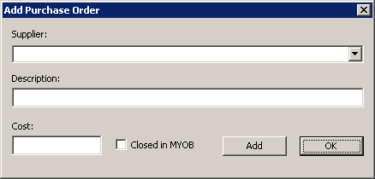 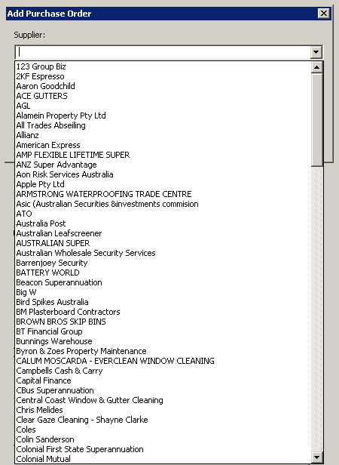

Clicking the “Add Purchase” button will give you this screen.

* Using the drop down list, select a supplier.
* Give a description of the purpose in the “Description” box.
* Type the cost in the “Cost” box.
* The “Closed in MYOB” checkbox allows you to set the purchase order as closed in MYOB.

Contact

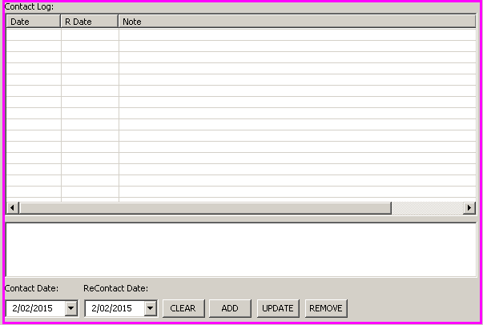

The contact section of the invoicing centre lets you view a contact log for the selected customer.

* The “Contact Date” and “ReContact Date” drop down calendars are used with the “ADD” and “UPDATE” buttons.
* After selecting a contact and a re-contact date. Click “ADD” to insert a new entry into the contact log.
* Selecting an entry in the contact log and clicking “UPDATE” will allow you to update the details of that entry.
* Clicking “CLEAR” will allow you to clear the notes field and reset the contact and re-contact dates to the current date.
* Selecting an entry in the contact log and clicking “REMOVE” will remove that entry from the contact log.

Menu

C:\Users\Jaws\Desktop\Work Pics\Colour Inv Centre.png

The menu section of the invoicing centre has controls that are used to edit the status of the invoice in addition to saving changes made and exiting the invoicing centre.

* The “OK” button save all changes made and exit the invoicing centre.
* The “Cancel” button exits the invoicing centre without saving any changes made.
* The “Refresh” button refreshes the page.
* The “Complete” button sets the job to a completed status.
* The “JOB” button will open the job card for that job.
* The “CUSTOMER” button will open the customer card for that customer.

After clicking on the “JOB” button, you may see a notification such as this:

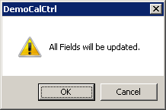

* Clicking “OK” means all changes made in the invoicing centre will be shown on the job card.
* Clicking “Cancel” means all changes made in the invoicing centre will *not* be shown on the job card.

After that the job card will be displayed:

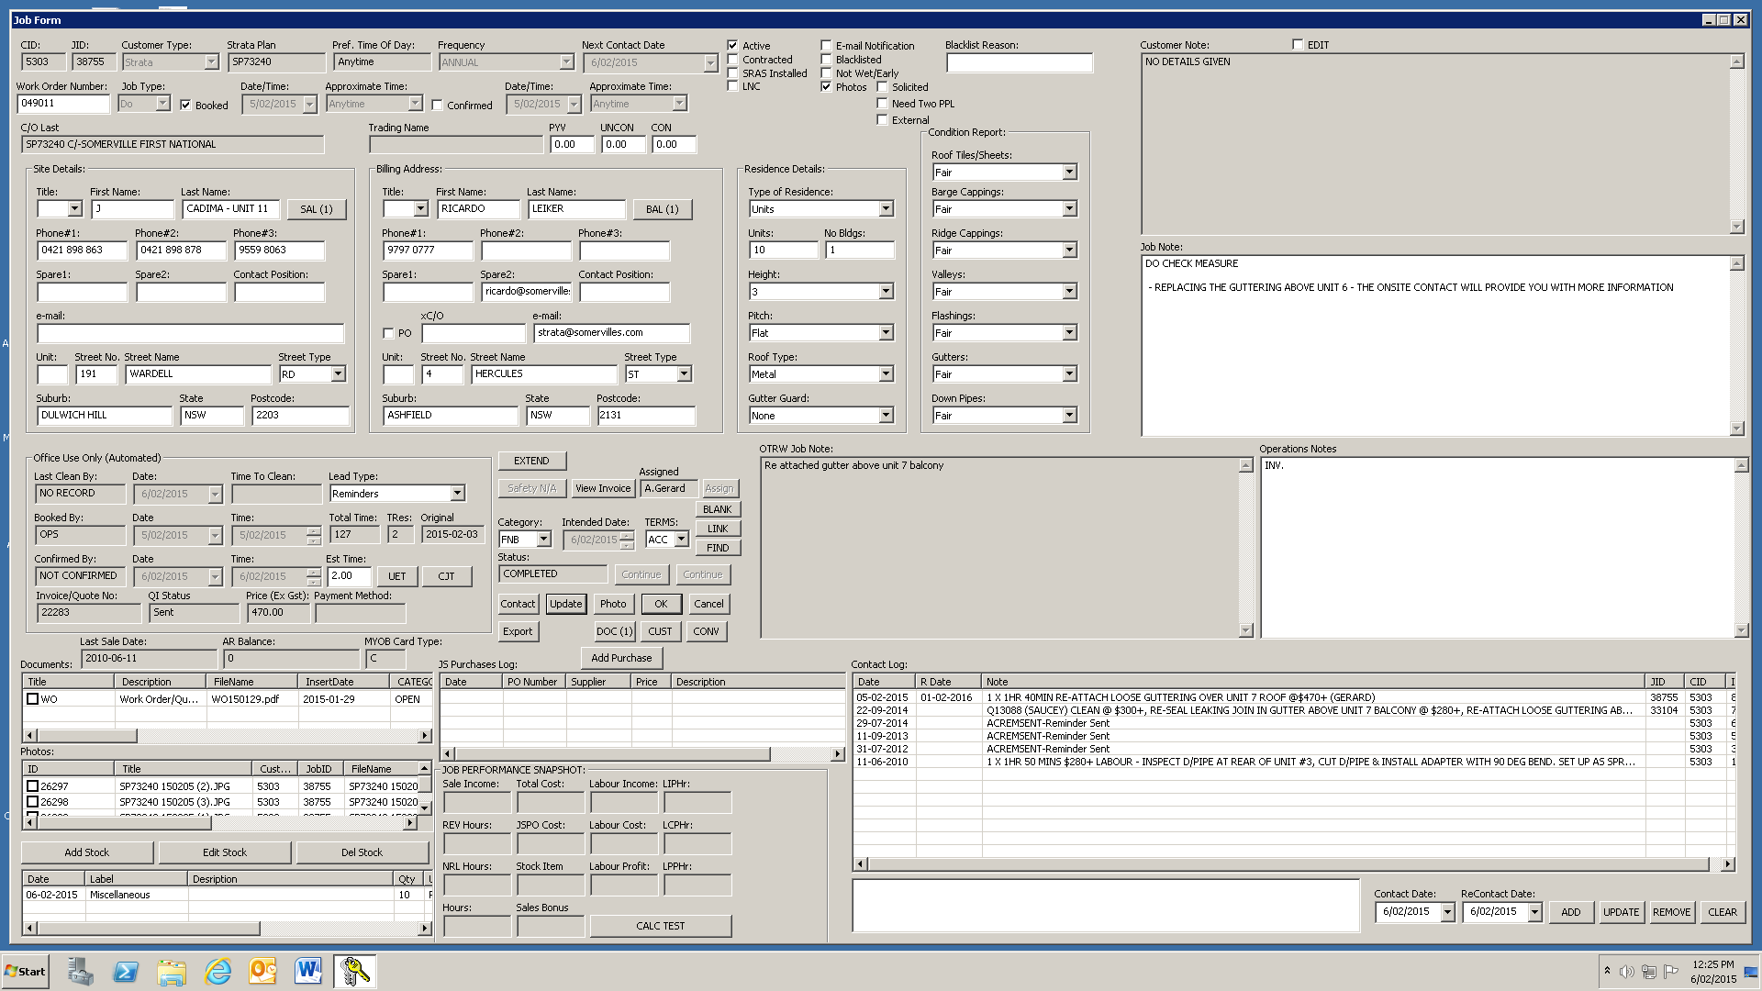

For information on the job card and its functions, please refer to “Job Form.pdf”.

After clicking on the “CUSTOMER” button, the customer card will be loaded:

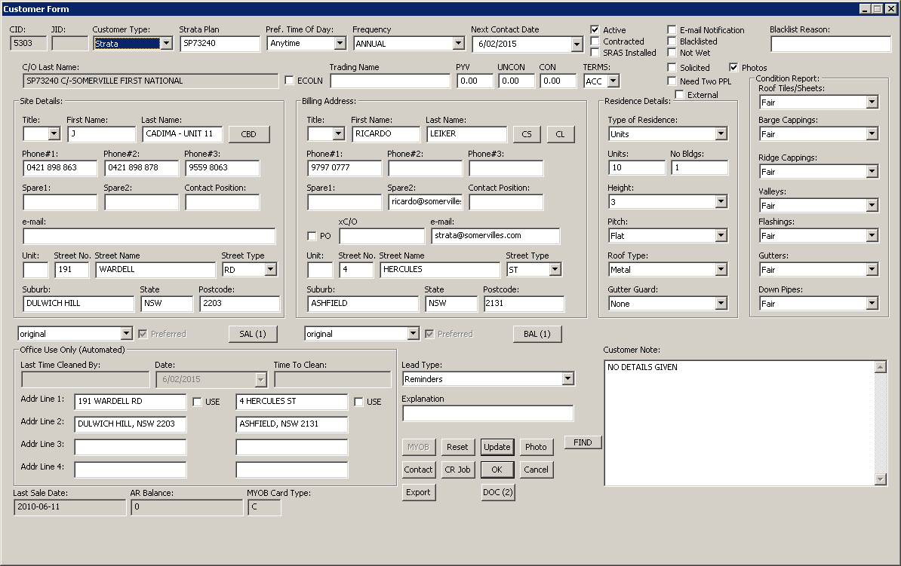

For more information on the customer card and its functions, please refer to “Customer Form.pdf”.